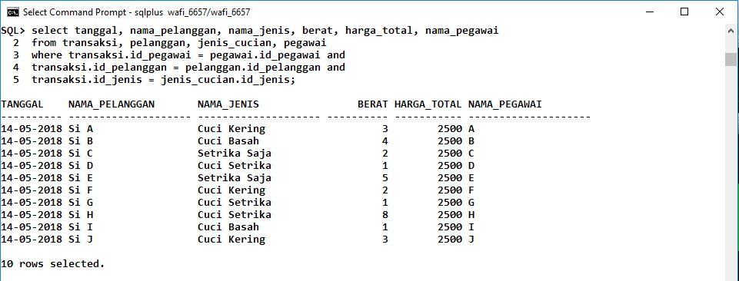

Keterangan Query :

------------------------------------------------------------------------------------------------------------------------------------------------------------------------------------------------------------------------------------------------------------------------------------------------------------------------------------------------------------------------------------------------------------------------------------------------------------------------------------------------------------------------------------------------------------------------------------------------------------------------------------------------------------------------------------------------------------------------------------------------------------------------------------------------------------------------------------------------------------------------------------------------------------------------------------------------------------------------------------------------------------------------------------------------------------------------------------------------------------------------------------------------------------------------------------------------------------------------------------------------------------------------------------------------------------------------------------------------------------------------------------------------------------------------------------------------------------------------------------------------------------------------------------------------------------------------------------------------------------------------------------------------